OWASP Juice Shop – Burp Suite Traffic Interception & Authentication Analysis

Overview
This lab documents the setup and use of Burp Suite Community Edition to intercept, analyse, and replay authentication traffic for OWASP Juice Shop, a deliberately vulnerable web application. The objective was to demonstrate practical skills in HTTP interception, request analysis, and backend interaction using industry-standard tooling in a fully legal lab environment.
The exercise was conducted as an independent, self-driven lab and is suitable for portfolio and project-based evaluation.

Lab Environment
- Operating System: Kali Linux (Debian-based)
- Target Application: OWASP Juice Shop
- Deployment Method: Docker container
- Target URL: http://localhost:3000
- Web Proxy Tool: Burp Suite (Community Edition)
- Browser Used: Burp Suite built-in browser

Scope of Testing
The scope of this lab was limited to:
- Configuring Burp Suite as an intercepting proxy
- Capturing HTTP traffic generated by the target application
- Intercepting authentication requests
- Replaying captured requests using Burp Repeater
- Observing server responses to modified and replayed requests
No automated scanning or unauthorized third-party testing was performed.

Methodology
- Proxy Configuration
Burp Suite was launched using default settings, and the proxy listener was verified to be running on 127.0.0.1:8080.
- Traffic Capture
The Burp built-in browser was used to ensure all application traffic passed through the proxy without localhost bypass issues.
- Request Observation
HTTP history was analyzed to confirm that requests to the Juice Shop application were being captured correctly.
- Authentication Interception
Login functionality was triggered with interception enabled at the correct stage to capture the authentication request.
- Request Replay & Analysis
The captured login request was sent to Burp Repeater, allowing direct interaction with the backend authentication endpoint and observation of server responses.

Key Findings
- Authentication requests are sent via a POST request to a RESTful endpoint.
- Credentials are transmitted in a structured request body, enabling direct backend testing independent of the frontend.
- Burp Repeater allows precise replay and manipulation of authentication requests, confirming backend behaviour and response handling.
- Successful login access was achieved, demonstrating effective control over the request/response lifecycle.

Screenshot Evidence & Captions

Screenshot 1: Burp Proxy Listener Configuration

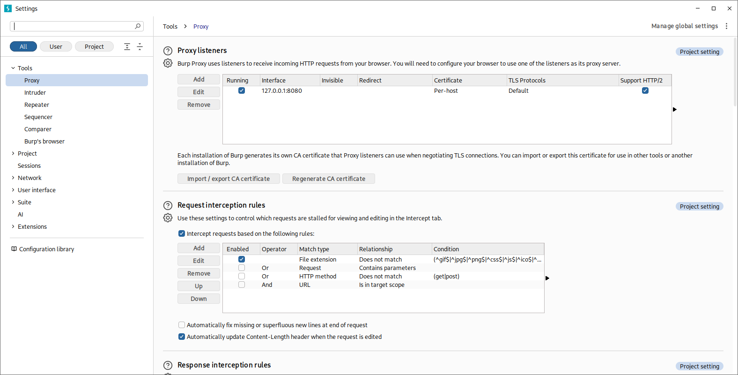
Burp Suite proxy listener running on localhost (127.0.0.1:8080), confirming correct interception setup.

Screenshot 2: Target Application Loaded in Burp Built-in Browser

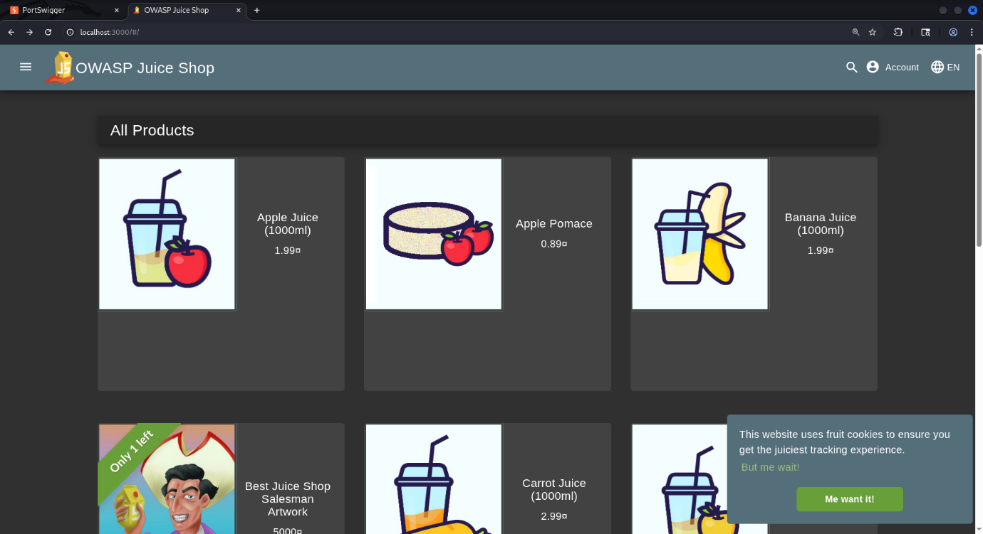
OWASP Juice Shop accessed via Burp’s built-in browser, ensuring all traffic is routed through the proxy.

Screenshot 3: HTTP History Showing Captured Application Traffic

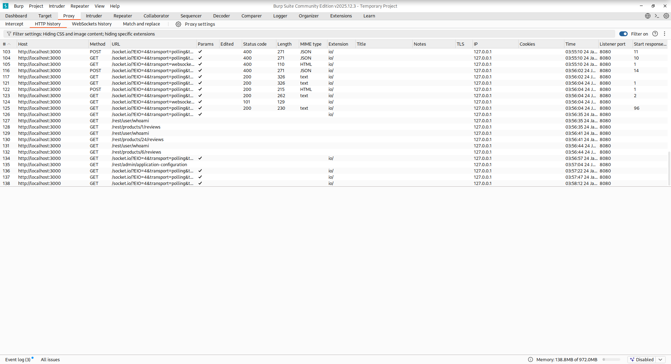
Captured HTTP requests generated by the Juice Shop application, validating successful traffic interception.

Screenshot 4: Intercepted Authentication Request

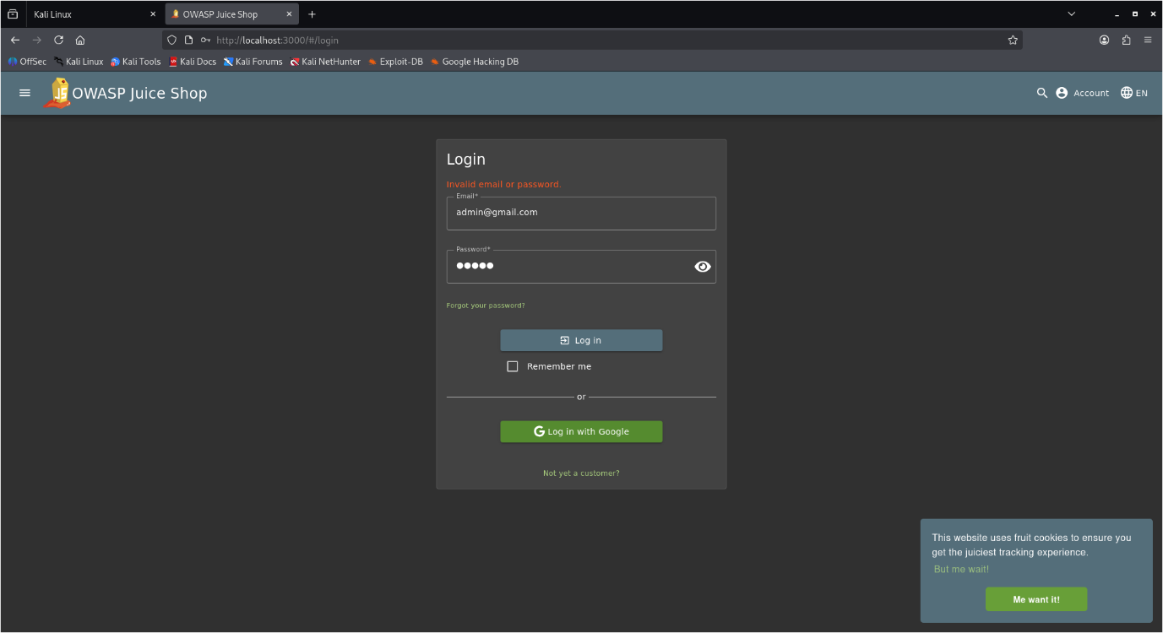

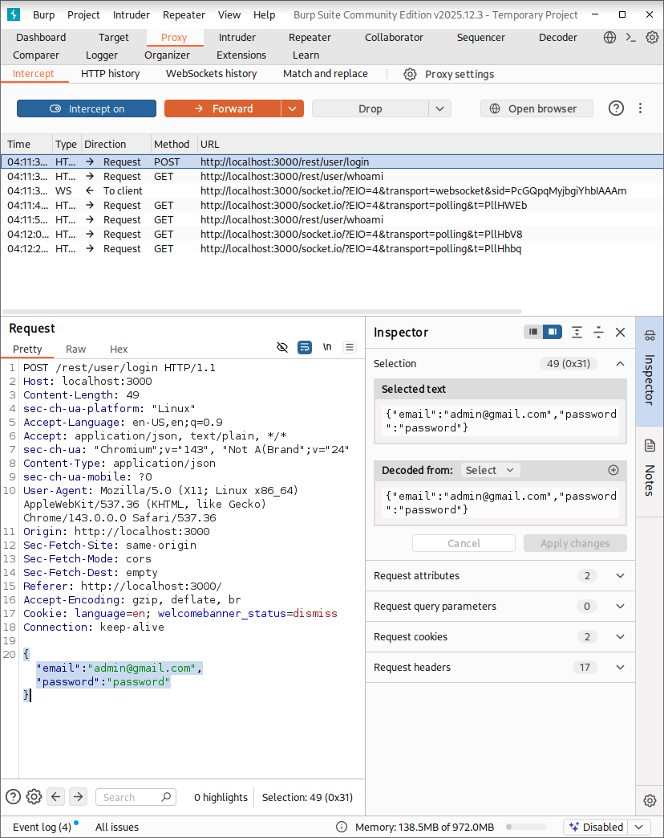
Login request intercepted in real time, exposing request method, endpoint, headers, and credential payload.

Screenshot 5: Authentication Request in Burp Repeater (Request View)

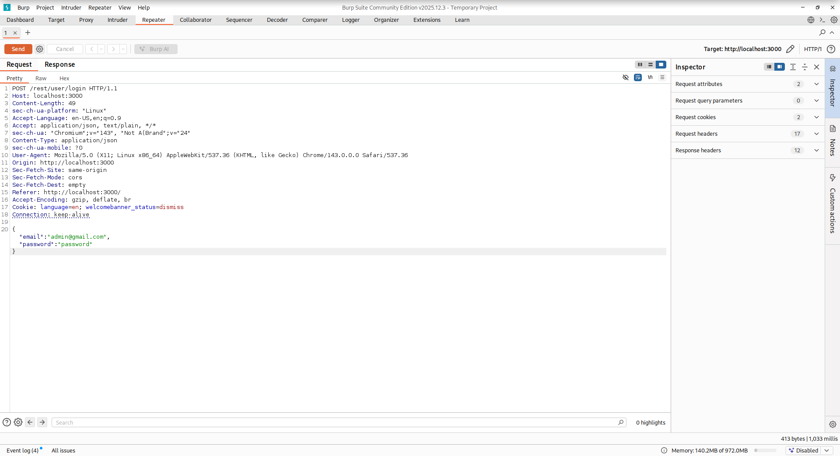

Captured login request loaded into Burp Repeater for manual replay and analysis.

Screenshot 6: Server Response Observed in Burp Repeater (Response View)

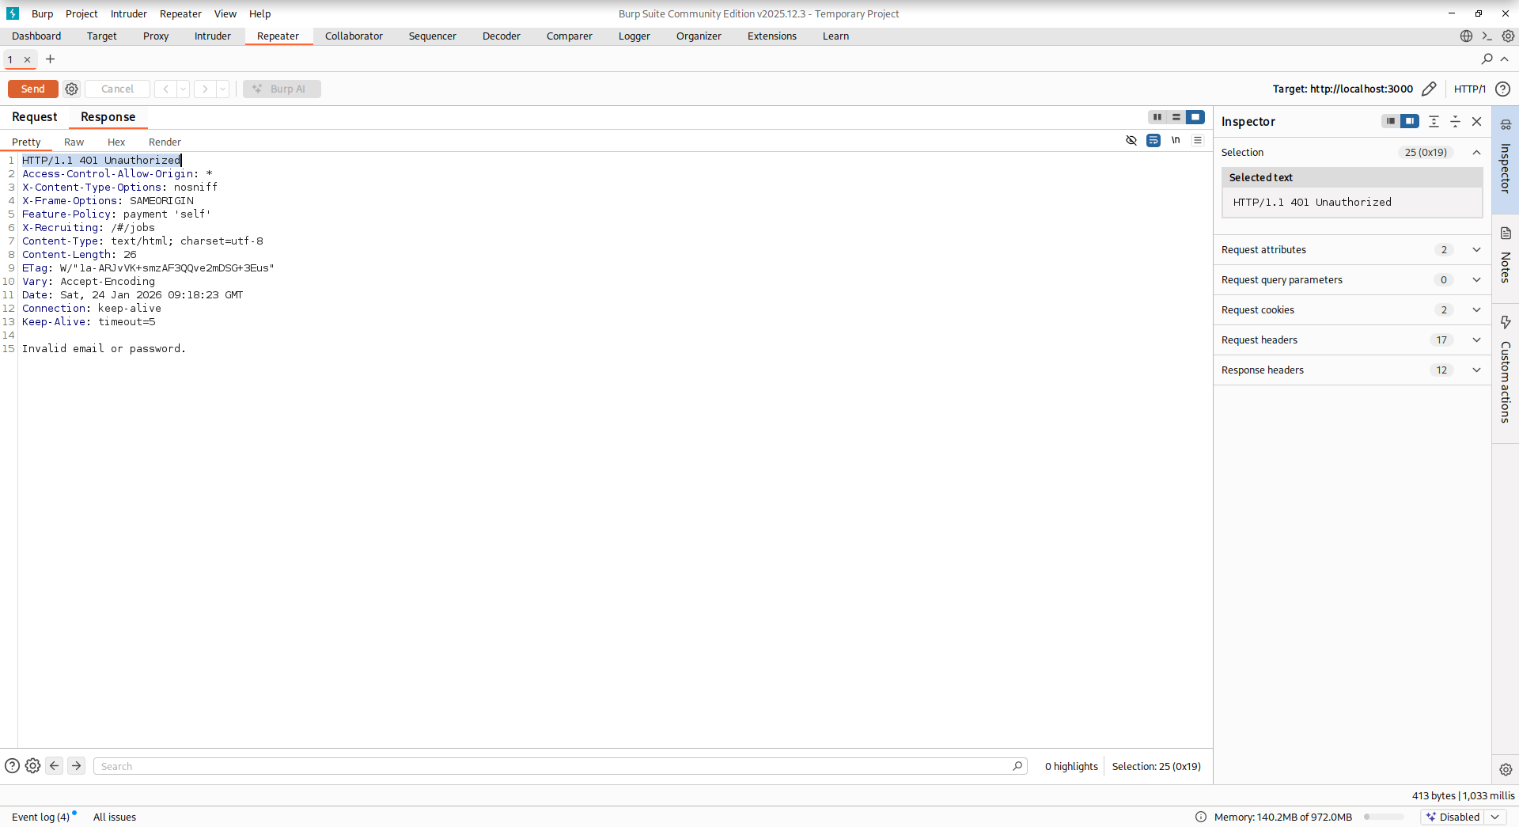
Backend server response received after replaying the authentication request, confirming direct interaction with the application logic.

Conclusion
This lab demonstrates practical proficiency with Burp Suite and a solid understanding of web authentication traffic analysis. The ability to intercept, inspect, and replay sensitive requests highlights readiness for more advanced vulnerability research, including authentication logic testing and injection-based flaws in controlled environments.

